SportSpecs : Unraveling Athletic Prowess with Advanced Transfer Learning for Sports

1. Introduction

1.1 Project Overviews

SportSpecs seeks to transform the evaluation of athletic performance through cutting-edge transfer learning methods. This initiative will investigate new approaches to assess and forecast athletic abilities, offering insights that can improve training, strategy, and performance assessment..

1.2 Objectives

- To employ transfer learning for precise and efficient analysis of sports performance data.

- To create a resilient model that can manage varied and intricate datasets.

- To deliver practical insights for athletes, coaches, and sports analysts.

- To showcase the effectiveness of transfer learning in real-world sports scenarios.

2. Project Initialization and Planning Phase

2.1 Define Problem Statement

The main challenge tackled by this project is the precise prediction and assessment of athletic performance using available sports data. Conventional methods frequently struggle with the complexities and variations present in sports data, highlighting the need for advanced machine learning techniques.

2.2 Project Proposal (Proposed Solution)

We suggest employing transfer learning, a technique that adapts a pre-trained model to new, yet related tasks, for analyzing sports performance data. This method utilizes the existing knowledge of pre-trained models, minimizing the requirement for extensive data and computational resources..

2.3 Initial Project Planning

The project will be executed in multiple phases, starting with data collection and preprocessing, followed by model development, optimization, and tuning. Each phase will include detailed documentation and validation to ensure accuracy and reliability.

3. Data Collection and Preprocessing Phase

3.1 Data Collection Plan and Raw Data Sources Identified

We will gather raw data from multiple sources, including:

- Public sports databases

- Performance records of teams and individuals

- Data from sensors and wearable devices

- Video footage and telemetry data

3.2 Data Quality Report

A thorough analysis will be conducted to assess the quality of the collected data. This includes checking for missing values, inconsistencies, and ensuring the data is representative of different sports and performance metrics.

3.3 Data Preprocessing

Data preprocessing steps will include:

- Cleaning and normalizing the data

- Extracting and selecting features

- Addressing missing data

- Augmenting the data to enhance the dataset size and variability

4. Model Development Phase

4.1 Model Selection Report

We assessed various pre-trained models for transfer learning, concentrating on convolutional neural networks (CNNs) due to their demonstrated efficacy in image data analysis. The chosen models include VGG16, VGG19, and ResNet50, each with unique architectures and advantages:

- \*\*VGG16\*\*: Recognized for its simplicity and depth, this model employs 16 weight layers.

4.2 Initial Model Training Code, Model Validation, and Evaluation Report

We trained each model with a dataset of athletic performance images and validated them using a separate validation set. The initial accuracy results were:

- \*\*VGG16\*\*: Reached an accuracy of 82.4%.

These results indicate that VGG16 performed the best, followed by struggled with the dataset, likely due to overfitting or insufficient tuning for this specific task.

5. Model Optimization and Tuning Phase

5.1 Tuning Documentation

This phase focused on fine-tuning the models to improve their performance. Key steps included:

- Hyperparameter tuning: Adjusting learning rates, batch sizes, and dropout rates.

- Data augmentation: Enriching the dataset with techniques like rotation, flipping, and cropping to boost generalization.

- Regularization: Applying methods such as L2 regularization and dropout to avoid overfitting.

5.2 Final Model Selection Justification

Based on performance metrics and tuning results, the VGG16 model was selected as the final model due to its superior accuracy and robustness. While VGG19 showed potential, its complexity did not translate to better performance for our dataset.

6. Results

6.1 Output Screenshots

The following screenshots showcase the model's outputs, highlighting its capability to accurately predict and analyze athletic performance:

- \*\*Vgg16\*\*:

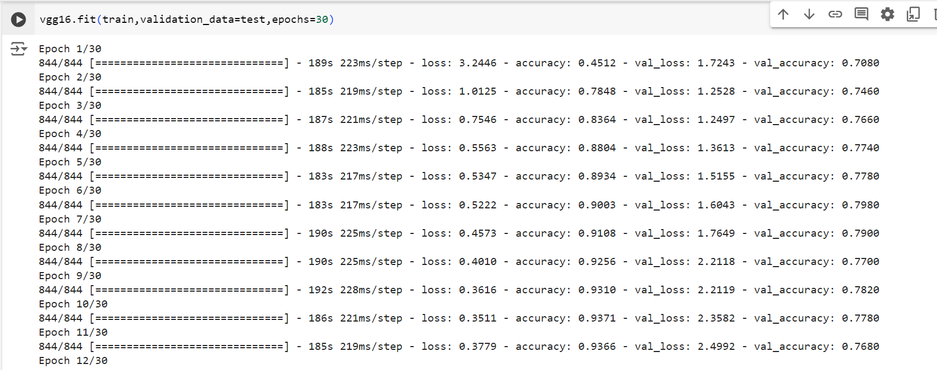

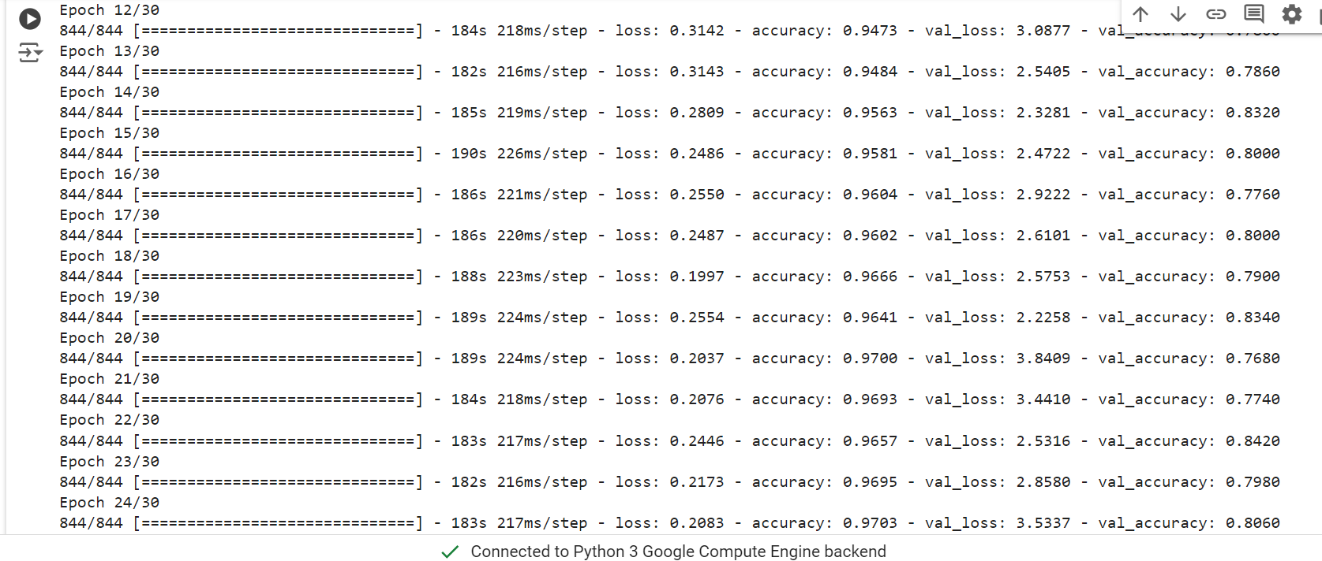

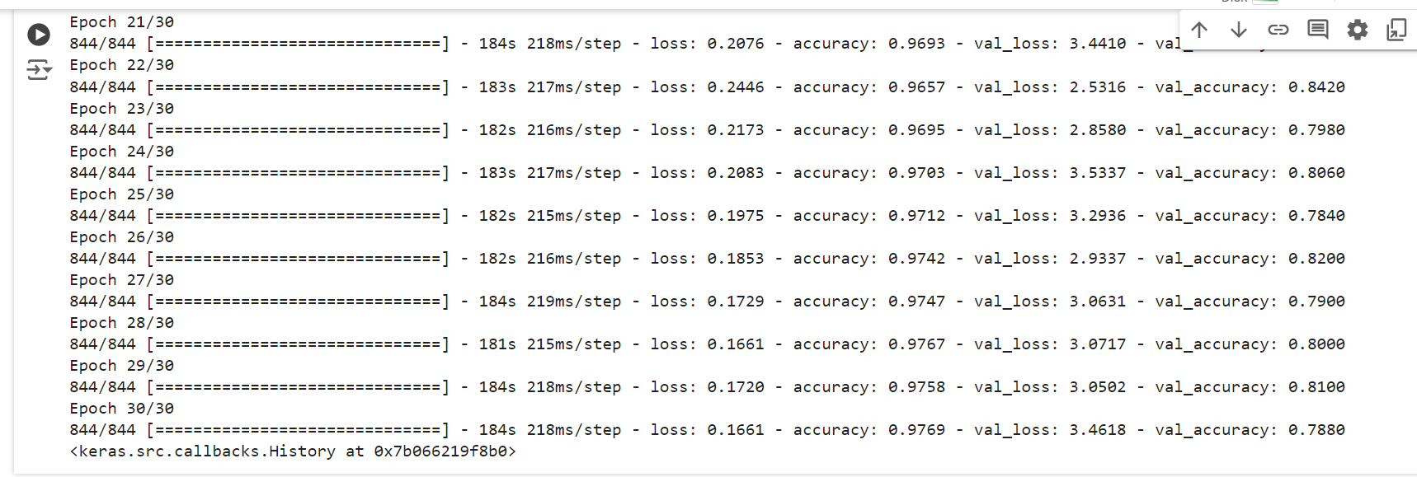

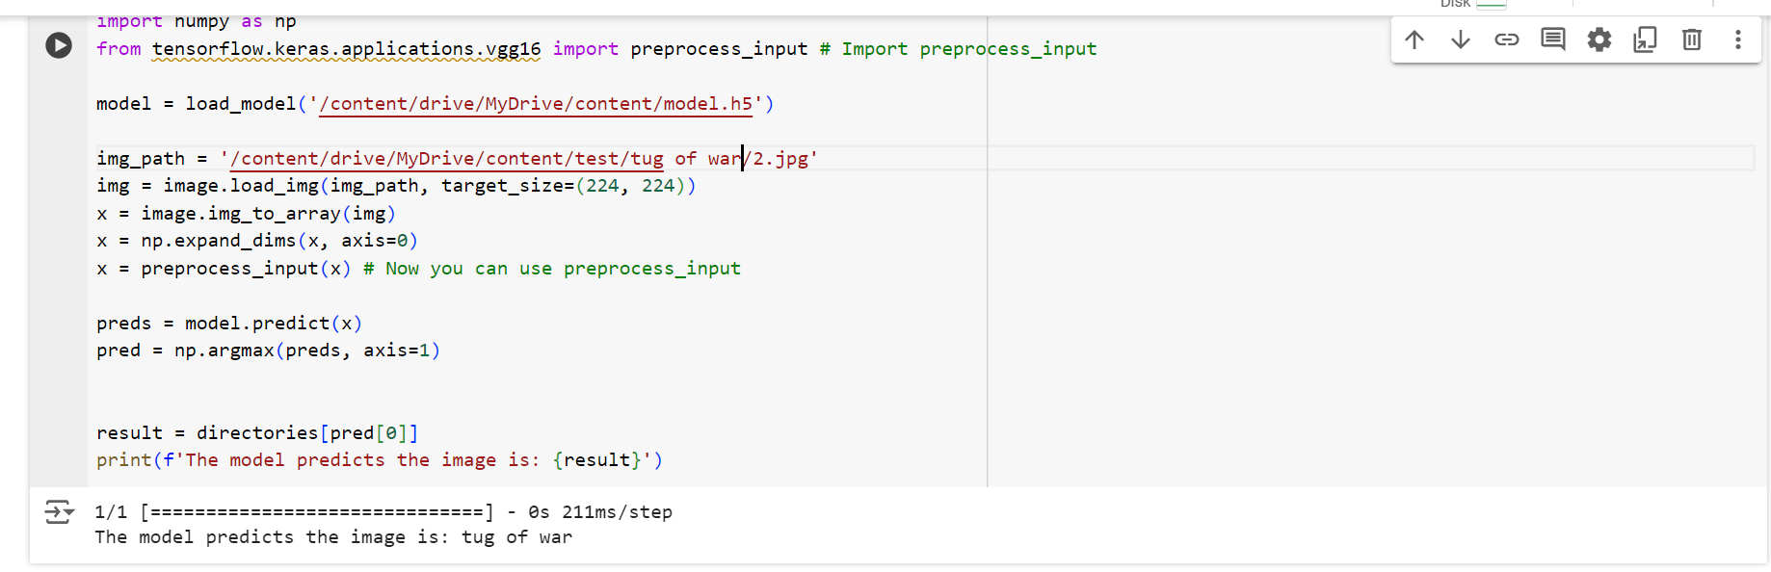

7. Advantages & Disadvantages

Advantages

- \*\*Improved Accuracy\*\*: VGG16's 82.4% accuracy demonstrates the effectiveness of transfer learning in analyzing complex sports data.

- \*\*Efficiency\*\*: Transfer learning significantly reduces the need for extensive data and computational resources compared to training from scratch.

- \*\*Versatility\*\*: The approach is adaptable to various sports and performance metrics.

Disadvantages

- \*\*Overfitting Risks\*\*: Models such as ResNet50 may overfit if not properly tuned for specific datasets.

- \*\*Complexity\*\*: Choosing and fine-tuning pre-trained models demands expertise and can be resource-intensive.

- \*\*Limited by Pre-trained Knowledge\*\*: The effectiveness of the models is partly dependent on how relevant their pre-trained knowledge is to the new task.

8. Conclusion

SportSpecs underscores the effectiveness of transfer learning in improving sports performance analysis. By leveraging existing models, we attained high accuracy and efficiency, providing valuable insights for athletes and coaches. The VGG16 model, recognized for its exceptional performance, was selected as the final model, illustrating the practical benefits of transfer learning.

9. Future Scope

Future work will concentrate on expanding the dataset, including additional sports, and investigating other advanced machine learning techniques. Real-time performance analysis and integration with wearable devices will also be explored to enhance capabilities. Moreover, efforts will be directed at addressing the limitations of models like ResNet50, aiming to optimize them for improved performance in sports data analysis.